Lumbar Patterns

Mechanical Back Pain
Mechanical pain originating from the spine can be categorised in many different ways. Below is a table designed to provide you with practical tips and advice on pain management for the most common types of lumbar pain.

 | Type 1  (commonly called “Disc pain”) | Type 2  (commonly called “Facet joint pain”) | Type 3  (commonly called “Sciatica”) | Type 4  (commonly called “Spinal stenosis”) | Type 5  (Other/Non-Mechanical)
LOCATION | Dominant symptoms are in the lower back, however buttock and leg pain may be present. | Dominant symptoms are in the lower back, however buttock and leg pain may be present. | The dominant symptoms are in the leg, back pain may also be present. | The dominant symptoms are in the leg/s, back pain may also be present. | The location may vary and may include, back/buttocks and leg pain
NATURE | Pain may be intermittent or constant with varying intensity | Pain is always intermittent | Pain is constant – occasionally intermittent if in chronic stage. | Pain is intermittent. | Pain is always constant and will remain unchanged through most movements or worsen at night
AGGRAVATING | Pain is made worse with flexion and sitting | Pain is made worse with extension based activity, standing and walking for prolonged periods | In the acute stage, most movements/activity will cause increased pain | Any activity that puts the spine into an extended position. People will normally have difficulty walking further than 100m | Most activity will aggravate the pain, and the pain will remain aggravated long after activity is ceased
EASING | Pain is better with extension based activity. Better to walk than it is to stand, better to stand than it is to sit. | Pain is relieved through sitting down, or bending forward. Often when standing it is more comfortable to have one foot raised | Pain is typically reduced when lying flat either in supine or prone, or with the legs lifted on a seat. | Sitting down or bending forward will abolish any leg symptoms within a few minutes. | It is unusual for any mechanical position/movement to be relieving
DAILY TIPS | The use of a lumbar roll when sitting is necessary in order to maintain the natural and appropriate curvature of the spine. | The use of a foot stool in sitting/standing can assist in bringing the pelvis to a more neutral position, therefore alleviating pressure through the spinal joints. | Maintenance of appropriate posture during normal tasks is required. Consult a health professional regarding the use of NSAID’s | When walking or standing, practice pulling the navel in and tilting the hips back, this will open the space between the joints and take the pressure of the nerves. | Consult a GP for further investigation to rule out any other pathologies, at this stage also discuss appropriate medications.
PAIN CONTROL | Repeated Extensions  -Lying on the stomach, slowly extend your arms in a push up fashion whilst keeping the hips down.  1 sets of 10 – hourly  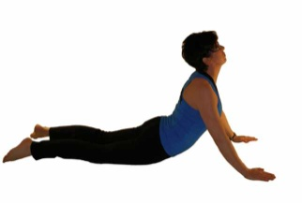 | Cat Stretch  - On hands and knees rock back so that the buttocks sit on the ankles. Return to 90⁰ of hip flexion only.  1 sets of 10 – hourly  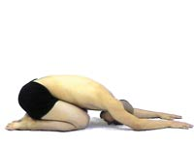 | Z Lying  - In the acute stage this may be necessary for the reduction of pain. Simply lie on the back with the legs on a chair  15 min max – hourly | Knees to Chest  -Bring both knees to the chest and then drop them back towards the floor by extending the arms.  3 sets of 10 – 2 hourly  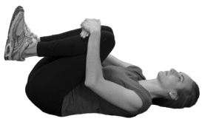 | Medication  - Given these symptoms are non-mechanical, most control positions/ movements will be ineffective in pain management.

