Headache disorders are common in today’s society amongst communities all around the world. It is one of the most common disorders and the nervous system. According to the World Health Organisation it is estimated that 47% of the adult population have had a headache in the last year. Headache disorders are a burden on society in regards to pain, disability, quality of life and financial costs. Only a small amount of headaches are correctly diagnosed or present to an appropriate clinician. The effects of headaches around the world has been under-recognised, underestimated and undertreated worldwide.
Type of Headache | Cervicogenic | Migraine | Cluster | Tension
Definition | Headache arising from the neck. Often associated with neck pain, sustained postures and neck movements. These headaches are usually mechanical in nature. | Headache lasting 4-72 hours. Has pulsating qualities, unilateral and severe in nature.  May be associated with aura, including blind spots, blurred vision and neural signs. | Headache that’s involves unilateral attacks of severe pain which is orbital, suborbital, temporal or any combination of the above. | Headache of infrequent episodes. The headache occurs bilaterally and is pressing in nature. Tension headaches have a moderate intensity and don’t change during routine physical activity.
Statistics | Up to 2.5% of the population will suffer from cervicogenic headaches, although figures can increase to 20% in pain management clinics | 10% of reported headaches are migraines.  Women are more prone to Migraines than men and usually occur from 35-45 years old. | 1 in every 1000 people will suffer cluster headaches at a rate of 6 men to 1 women.  Normal presentation is from 20 years old and above. | Episodic tension headaches have been reported by up to 70% of the population in certain communities.  Chronic tension headaches affect 1-3 % of the population.
Diagnostic Criteria | 1. Restricted neck movements on active movements (most notable into extension and rotation)  2. Positive findings on manual examination on the upper cervical spine at O-C1, C1-2 and C2-3 joints on passive accessory and passive physiological movements  3. Decreased strength and endurance in the deep neck flexors and performance of the cranio-cervical flexion test, which is usually associated with increased tension in the cervical extensor muscles. | At least 5 attacks from the following criteria:  a) Headache lasting 4-72 hours;  b) Headache including at least 2 of the following;  - Unilateral  - Pulsating quality  - Moderate to severe intensity  - Aggravating or avoidance of routine physical activity  C) During headache at least one of the following;  - Nausea and/or vomiting  - Phonophobia or photophobia | At least 5 attacks from the following criteria:  a) Headache lasting 15-180 minutes  b) Headache including at least 1 of the following;  - Ipsilateral eyelid oedema  - Ipsilateral forehead sweating  - Ipsilateral nasal congestion  - Restless, agitated  - Ipsilateral ptosis (drooping of the eye lid)  - Ipsilateral conjunctiva (redness of eye)  - Ipsilateral tears  C) Attacks have a frequency of every other day to 8 per day | At least 10 episodes occurring less than 1 day per month on average  a) Headache last 30 minutes to 7 days  b) Headache including at least 2 of the following  - Bilateral  - Pressing/  tightening  - Mild to moderate  - Not aggravated by routine exercise  C)Has both of the following;  - No nausea or vomiting  - No more than 1 photophobia or phonophobia
Location | 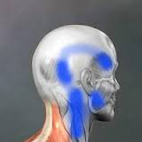 | 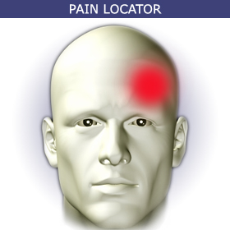 | 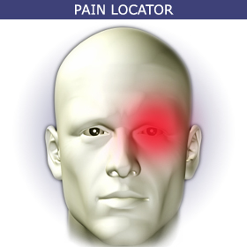 | 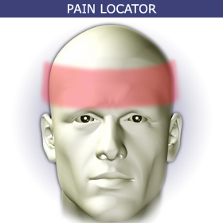
Cause/Aggravating factors | Poor work postures, increased computer time, stomach sleepers.  Cervical spine tightness/stiffness or dysfunction. | Hormonal changes, disturbed sleep, foods, unusual smells and stress. | The cause of cluster headaches is still unknown. Theories exist that the hypothalamus (area of the brain controlling temperature, hunger and thirst) is an integral component of these headaches.  Alcohol, hormones and temperature changes may also contribute to these headaches. | Poor evidence exists for the cause of tension headaches. Experts have theorized that increased muscle contraction in the neck, face or scalp play a major role, usually occurring alongside stress and/or emotional changes.
Reported easing  factors | Stretching, manual pressure, massage, manual treatment. | Dark rooms, silence | Nothing as it comes in intermittent waves. | Hot or cold showers, rest
Treatment options | 1. Manual therapy including massage, joint mobilisation and manipulation;  2. Muscle strengthening and coordination programs;  3. Postural correction exercises. | 1. Bed rest  2. Medical interventions including beta blockers, Triptan’s, Sandomigrane  3. Manual therapy can help associated spasm, joint stiffness and neural referral. | 1. Oxygen inhalation  2. Medical interventions including;  Triptans, dihydroergotamine, nasal drops. | 1. Medications including pain relievers, triptans, narcotics;  2. Postural changes;  3. Hot/cold therapy;  4. Acupuncture, massage;  5. Deep breathing; exercises

Cochrane review shows level 1 evidence for the use of physiotherapy in treating cervicogenic headache (Pod cast refer if needed). Which is good for cervicogenic strategies
Gwen Jull, Spine 2002 article which shows evidence which shows good evidence for exercise and physiotherapy.
Gwen Jull look up for 3 tests shown above as evidence for diagnose

http://www.who.int/mediacentre/factsheets/fs277/en/

Acupun ture for tension headaches put in Cochran review
Jull G, Trott P, Potter H, et al. A randomized controlled trial of exercise and manipulative
therapy for cervicogenic headache. Spine 2002:27:1835–45.
Stats come from WHO,
http://www.jaoa.org/content/105/4_suppl/16S.full

